EVENT ANNOUNCEMENT EMAIL- PARENTS
PLEASE USE HEADER IMAGE BELOW

Subject: Help [INSERT SCHOOL NAME] In Our Recycle Rally Journey Today!

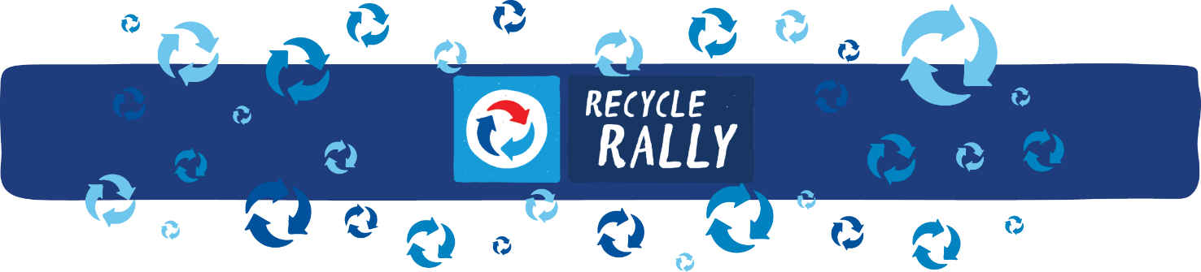

Parents,

[INSERT SCHOOL NAME] is excited to be participating in the Recycle Rally competition again this year, and we could use your help to become one step closer to our recycling goals!

What is PepsiCo’s Recycle Rally?
- Recycle Rally is a nationwide program designed to raise awareness of recycling in K-12 schools.
- The program teaches students about the importance of recycling and inspires them to make recycling a part of their daily lives.
- By participating, schools have the opportunity to win prizes, set and achieve recycling goals, utilize effective educational tools, and connect with a national school recycling network.
- Schools can earn rewards points for each plastic bottle* and can recycled and can redeem the points for prizes and merchandise to help the school. Frequent contests also offer opportunities to earn gift cards and cash prizes ranging up to $1,000
How can you help [INSERT SCHOOL] on their Recycle Rally journey?
- [INSERT SCHOOL] is hosting a community-wide recycling drive [INSERT DATE, TIME, PLACE].
- Send your kids to school with empty aluminum cans and plastic bottles to donate to the drive.
- Invite family, friends, and members of the community to donate their aluminum cans and plastics bottles.

What’s in it for the students and school?
- Increases recycling awareness and action in their daily lives to make an impact on the environment
- Provides opportunity for team collaboration and leadership skills
- Involves school groups and broader community
- Fosters schools spirit and pride for community

We hope you consider helping [INSERT SCHOOL] become one step closer to our recycling goals!

[INSERT SIGNATURE for EMAIL SENDER]
*Plastic #1 (PETE) & #2 (HDPE) beverage bottles

